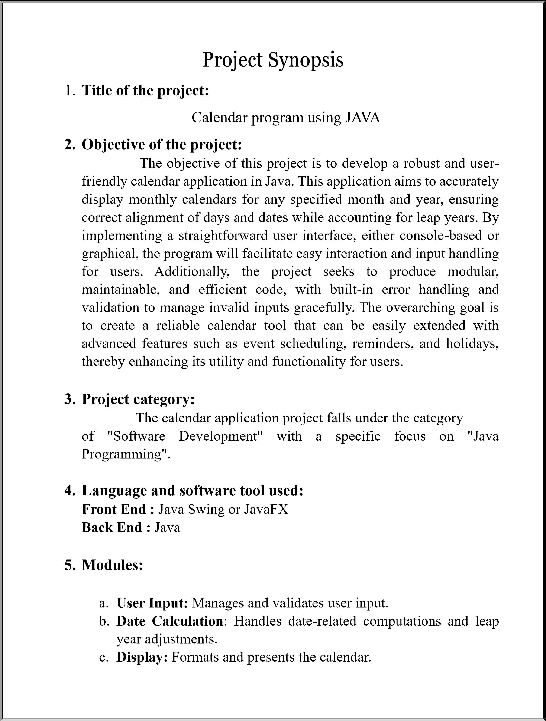

d.

**Error Handling**

Manages and reports errors.

:

e.

**User Interface (optional)**

**:**

Provides a graphical interface using

Java Swing or JavaFX.

f.

**Testing**

**:**

Ensures functionality and integration through tests.

g.

**Documentation**

**:**

Provides code comments and user guides.

Archita Patra

N

andinee Das

P

rat

yush K

u. Pradhan

Saniya Pradhan

Smruti

smita

Dehury